**LAB ASSIGNMENT 01**

**COMSATS University Islamabad**

Sahiwal Campus



***Usama Sarwar***

FA17-BS(CS)-090-B

***Mr. Waqar***

Artificial Intelligence

October 12, 2020

Table of Contents

1. Artificial Intelligence 1

2. Machine learning VS Deep Learning VS artificial Intelligence 1

3. Problem solving technique 1

3.1 Problem Searching 1

3.1.1 Problem 1

3.2 Steps involve in Solving Problems Using Artificial Intelligence 2

3.3 Example: 3

3.3.1 8 Puzzle Problem: 3

4. IDE for Python 3

4.1 Comparison Chart 4

5. AIML (Artificial Intelligence Markup Language) 5

5.1 Use of AIML 5

5.2 Basic tags of AIML 5

6. Data types in python 5

6.1 Numeric 5

6.2 Boolean 6

6.3 Sequence 6

6.4 Dictionary 6

7. Programs in python 6

7.1 Take a number from user and find the Factorial of this Number 6

7.2 Write a Python program which accepts a sequence of comma-separated numbers from user and generate a list and a tuple with those numbers. Also update tuple elements. 7

7.3 Write a program to take kilometers from the user convert it into miles 8

7.4 Write a program to swap two elements in a list 8

7.5 The program takes the elements of the list one by one and displays the average of the elements of the list 9

7.6 Write a python program to implement List operations 9

# Artificial Intelligence

Artificial intelligence (AI) is the simulation of human intelligence in machines that are programmed to think and act like humans by mimicking their actions. The term may likewise be applied to any machine that shows qualities related with a human psyche, for example, learning and critical thinking. The ideal trait of Artificial Intelligence is its capacity to justify and take activities that have the most obvious opportunity with regards to accomplishing a particular objective.

# Machine learning VS Deep Learning VS artificial Intelligence

**Artificial Intelligence** is a science like arithmetic or science. It contemplates approaches to fabricate insightful projects and machines that can innovatively take care of issues, which has consistently been viewed as a human right.

**Machine learning** is a subset of artificial intelligence (AI) that gives frameworks the capacity to consequently take in and improve for a fact without being expressly customized. In ML, there are various calculations (for example neural organizations) that help to tackle issues. It has techniques that helps computers to figure things out and deliver the outcome to AI.

**Deep Learning** is a subset of machine learning, which utilizes the neural organizations to investigate various variables with a structure that is like the human neural framework. It helps computers to solve more complex problems.

# Problem solving technique

According to psychology, “a problem-solving refers to a state where we wish to reach to a definite goal from a present state or condition.

According to computer science, a problem-solving is a part of artificial intelligence which encompasses a number of techniques such as algorithms, heuristics to solve a problem.

## Problem Searching

* In general, searching refers to as finding information one needs.
* Searching is the easiest and commonly used technique of problem solving in artificial intelligence.
* Searching algorithm helps us to search for solution of particular problem.

### Problem

* Problems are the issues which comes across any system at any point of time. A solution is always needed to solve that particular problem.

## Steps involve in Solving Problems Using Artificial Intelligence

* The process of solving a problem consists of five steps. These are:

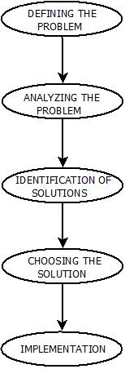

**Problem Solving in Artificial Intelligence**

**Defining the Problem:** The definition of the problem must be included precisely. It should contain the possible initial as well as final situations which should result in acceptable solution.

1. **Analyzing the Problem:** Analyzing the problem and its requirement must be done as few features can have immense impact on the resulting solution.
2. **Identification of Solutions:** This phase generates reasonable amount of solutions to the given problem in a particular range.
3. **Choosing a Solution:** From all the identified solutions, the best solution is chosen basis on the results produced by respective solutions.
4. **Implementation**: After choosing the best solution, its implementation is done.

## Example:

### 8 Puzzle Problem:

* Here, we have a 3×3 matrix with movable tiles numbered from 1 to 8 with a blank space. The tile adjacent to the blank space can slide into that space. The objective is to reach a specified goal state similar to the goal state, as shown in the below figure.
* In the figure, our task is to convert the current state into goal state by sliding digits into the blank space.

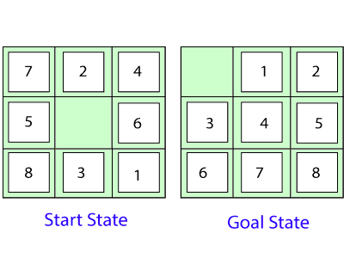

In the above figure, our task is to convert the current (Start) state into goal state by sliding digits into the blank space.

**The problem formulation is as follows:**

* **States:** It describes the location of each numbered tiles and the blank tile.
* **Initial State:** We can start from any state as the initial state.
* **Actions:** Here, actions of the blank space are defined, i.e., either **left, right, up, or down**
* **Transition Model:** It returns the resulting state as per the given state and actions.
* **Goal test:** It identifies whether we have reached the correct goal-state.
* **Path cost:** The path cost is the number of steps in the path where the cost of each step is 1.

# IDE for Python

An IDE (or Integrated Development Environment) is a program devoted to programming development. As the name suggests, IDEs coordinate a few devices explicitly intended for programming development. These devices normally include:

* An editor intended to deal with code (with, for instance, language structure featuring and auto-fulfillment)
* Construct, execution, and investigating devices
* Some type of source control

There are two major categories of Python IDEs as follows:

* General Editors and IDEs with Python Support
* Python Specific Editors and IDEs

## Comparison Chart

|  |  |  |  |
| --- | --- | --- | --- |
| IDE | Price | Supported Platform | Category |
| Pycharm | US $ 199 per User – 1st year for Professional Developer. | WINDOWS, LINUX, MAC etc. | Python Specific |
| Spyder | Open Source | QT, WINDOWS, LINUX, MAC OS etc. | Python Specific |
| PyDev | Open Source | QT, WINDOWS, LINUX, MAC OS etc. | General |
| Idle | Open Source | WINDOWS, LINUX, MAC OS etc. | General |
| Wing | US $ 95 to US $ 179 PER USER FOR COMMERCIAL USE. | WINDOWS, LINUX, MAC OS etc. | General |
| Eric Python | Open Source | WINDOWS, LINUX, MAC OS etc. | General |
| Rodeo | Open Source | WINDOWS, LINUX, MAC OS etc. | General |
| Sublime Text | USD $80 | WINDOWS, LINUX, MAC OS etc. | General |
| Atom | Open Source | WINDOWS, LINUX, MAC OS etc. | General |
| Vim | Open Source | WINDOWS, LINUX, Mac OS, IOS, Android, UNIX, AmigaOS, MorphOS etc. | General |
| Visual Studio Code | Open Source | WINDOWS, LINUX, Mac OS etc. | General |

# AIML (Artificial Intelligence Markup Language)

AIML stands for Artificial Intelligence Modelling Language. AIML is an XML based markup language meant to create artificial intelligent applications. AIML makes it possible to create human interfaces while keeping the implementation simple to program, easy to understand and highly maintainable.

## Use of AIML

* AIML stands for Artificial Intelligence Modelling Language.
* AIML is an XML based markup language meant to create artificial intelligent applications.
* AIML makes it possible to create human interfaces while keeping the implementation simple to program, easy to understand and highly maintainable.

## Basic tags of AIML

* **<aiml>** − defines the beginning and end of a AIML document.

<aiml version = "1.0.1" encoding = "UTF-8"?>

...

</aiml>

* **<category>** − defines the **unit of knowledge** in Alicebot's knowledge base.
* **<pattern>** − defines the pattern to match what a user may input to an Alicebot.
* **<template>** − defines the response of an Alicebot to user's input.

<category>

<pattern> Usama Sarwar </pattern>

<template>Hello World </template>

</category>

# Data types in python

## Numeric

It is used to represent data which is in numeric form. Three types of numeric data:

**Integers(int):** Positive or negative whole numbers without decimal part **i.e.** 1,2,3 ,etc/

**Float:** Positive or negative numbers with decimal part **e.g.** 10.1, 30.5, etc

**Complex Numbers:** A number with a real and imaginary component represented as x+yj. x and y are floats and j is -1(square root of -1 called an imaginary number).

## Boolean

Data with one of two built-in values True or False. true and false are not valid booleans and Python will throw an error for them.

## Sequence

A sequence is an ordered collection of similar or different data types. Python has the following built-in sequence data types:

* **String**: A string value is a collection of one or more characters put in single, double or triple quotes. **E.g**. Usama Sarwar, etc.
* **List** : A list object is an ordered collection of one or more data items, not necessarily of the same type, put in square brackets. **E.g.** [1,2,4], etc.
* **Tuple**: A Tuple object is an ordered collection of one or more data items, not necessarily of the same type, put in parentheses. **E.g. (**a,b,c**) , etc.**

## Dictionary

A dictionary object is an unordered collection of data in a key:value pair form. A collection of such pairs is enclosed in curly brackets. For example: {1:"Steve", 2:"Bill", 3:"Ram", 4: "Farha"}

# Programs in python

## Take a number from user and find the Factorial of this Number

num = int(input("Number: "))

factorial = 1

if num < 0:

    print("No Factorial for Negative Numbers")

elif num == 0:

    print("The factorial of 0 is 1")

else:

    for i in range(1, num + 1):

        factorial = factorial*i

    print("The factorial of", num, "is", factorial)

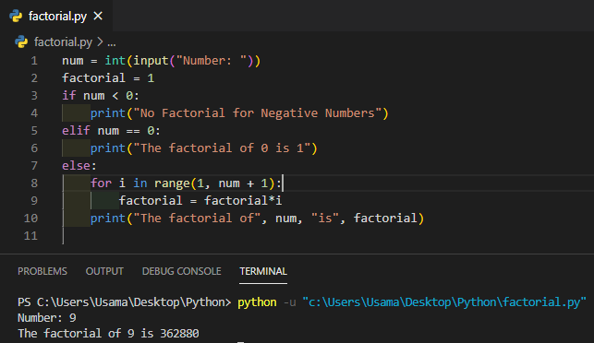

## Write a Python program which accepts a sequence of comma-separated numbers from user and generate a list and a tuple with those numbers. Also update tuple elements.

Tuples can not be updated.

values = input("Comma Seprated Numbers: ")

list = values.split(",") # convert to list

print('List : ',list)

tuple = tuple(list)  # convert to tuple

print('Tuple : ',tuple)

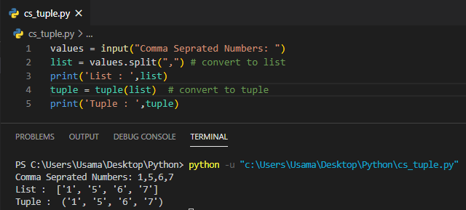

## Write a program to take kilometers from the user convert it into miles

# Collect input from the user

kilometers = float(input('How many kilometers?: '))

conv_fac = 0.621371  # conversion factor

miles = kilometers * conv_fac  # calculate miles

print('%0.3f kilometers is equal to %0.3f miles' %(kilometers,miles))

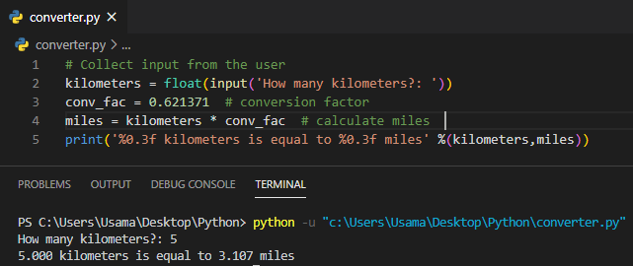

## Write a program to swap two elements in a list

def swapPositions(list, pos1, pos2):

    list[pos1], list[pos2] = list[pos2], list[pos1]

    return list

values = input("Input some comma seprated numbers : ")

list = values.split(",")  # convert to list

print('Original list is : ', list)

pos1, pos2 = 1, 3

print('Swaped list is : ',swapPositions(list, pos1-1, pos2-1))

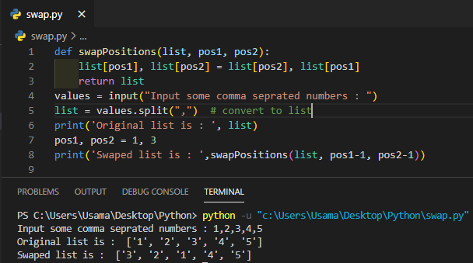

## The program takes the elements of the list one by one and displays the average of the elements of the list

def Average(lst):

    return sum(lst) / len(lst)

list= [1,2,3,4,5]

print('Original list is : ', list)

average = Average(list)

print("Average of the list =", round(average, 2))

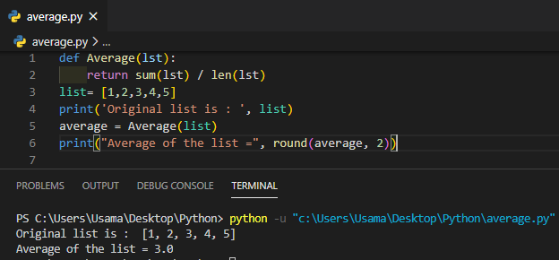

## Write a python program to implement List operations

(Nested List, Length, Concatenation, Membership, Iteration, Indexing and Slicing)

my_list = [1, "Hello", 3.4, 5,8,9]

print("List is:", my_list)

# nested list

n_list = ["mouse", [8, 4, 6], ['a']]

print("List is:", n_list)

# List indexing

print(my_list[0])

print(my_list[2])

print(my_list[4])

# Nested List

# Nested indexing

print(n_list[0][1])

print(n_list[1][2])

# List slicing in Python

# elements 3rd to 5th

print(my_list[2:5])

#elements beginning to 4th

print(my_list[:-5])

# elements 6th to end

print(my_list[5:])

# elements beginning to end

print(my_list[:])

# List Membership using in operator

print('mouse' in my_list)

print('a' in my_list)

print(9 not in my_list)

#iteration

for fruit in ['apple','banana','mango']:

    print("I like",fruit)

